|  |  |
| --- | --- |
| **WOODSIDE SCHOOL** | |
| **Curriculum Policy** | |
| **Last external review** | January 2025 |
| **Next external review** | January 2026 |
| **Last update** | February 2025 |

# **INTRODUCTION**

Most pupils attending Woodside School have an Educational & Health Care Plan (EHCP). Most pupils are working below or significantly below their expected age levels, and often have a range of social, emotional, and mental health issues and mild to severe learning disabilities. The curriculum is differentiated to accommodate for this, and we teach “stage not age.” This means that teaching groups often comprise of mixed age groups, with a wide range of abilities from ages 8 – 17 who are not working at their age-related expectations.

Our curriculum is created to meet the students at Woodside School, with an understanding that the individual needs of the students, requires a broad and holistic approach. Our high aim is for every student to reach his/her fullest potential, becoming an independent and thriving member of society. In order to achieve this, we have adapted curriculum into differentiated pathways providing a clear and ambitious pathway enabling the development of skills, knowledge, and understanding.

Adapting the Equals curriculum into our dedicated teaching approach, consisting of building strong engagement in an experiential and project-based methodology, allowing for individual focus within a purposeful and integrated environment.

Our curriculum provides a coherent framework in which outcomes in the areas of Education, Health and Care Plans, our adapted curriculum, learning pillars, accredited learning, PSHE/SMSC/RSE, and all other areas of learning are combined to form a holistic learning pathway for each student.

The outcome of our curriculum is that our students are able to successfully transition to their post-school placements and to thrive as confident, competent, and connected members of their community.

**SCOPE**

This policy will impact all members of the school community, including at our school, staff, students, families, and other stakeholders in the community.

**APPROACH**

**Guiding philosophy**

Our philosophy is centred around the Montessori principles developed by Dr. Maria Montessori over many years of experimentation and observation.

* Respect for the child
* Absorbent mind
* Sensitive periods
* Educating the whole child
* Individualised learning
* Freedom of movement and choice
* Prepared environment
* Intrinsic motivation
* Independence
* Auto-education

The guiding element of the approach we take supports the developmental path of students in the following three stages: ‘Building community’, ‘Diverse Learning’ and ‘Developing Independence’. Each supports and transitions into the next, creating a learning journey that is inclusive of everyone while emphasising the diverse needs of the student body.

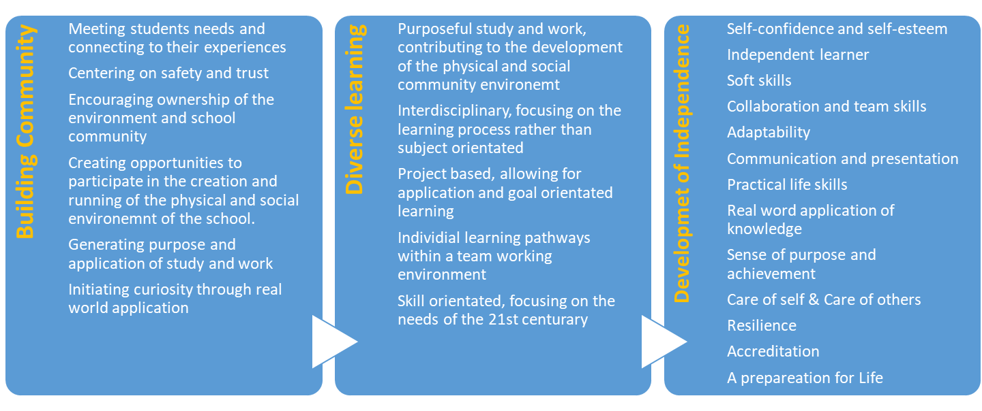

Community Engagement is a vital aspect of our approach, focusing on building the physical and social environment as a community of students and adults. This supports with generating interest, purpose, curiosity, communication and relationships, ultimate creating a sense of ownership for a student over their learning and development. Students contribute to the community at their own level and capability, providing inclusive space and opportunity for all.

Emphasising Community provides a platform to offer a diverse learning experience that includes opportunities that stem from Community projects, themes, and events. These are purposeful and experiential goal orientated opportunities that support the rounded nature of the development and progress sought after.

From this diverse learning experiences, comes the development of independence, from a practical perspective to a learning perspective and finally as a Preparation for Life.

**Intent, Implementation, Impact Summary**

|  |  |  |
| --- | --- | --- |
| **Intent** | **Implementation** | **Impact** |
| Implement Quality of Life framework | Working in partnership with parents, carers, teachers, local authorities, and communities. | Fostering positive and transparent relationships with the world around the young people. |
| Implement Equals Curriculum | Holistic cross curriculum theme and project-based approaches, that embed Social, Moral, Spiritual, and Cultural aspects of life and fulfils and ties in with the Fundamental British School Values. | Experience in linguistic, mathematical, scientific, technological, human and social, physical and aesthetic and creative education. Progress and grow becoming confident and independent in their learning, with good problem-solving skills and executive functioning skills. |
| Baseline assessment to navigate the pathways | Use SCERTS, Identiplay, Boxhall profiling, Baselining in Maths and English, access to Speech and Language and Occupational Therapy assessments, and working alongside multi-agencies. | Meet the child and their current needs and measure growth and progression over time within our holistic Curriculum. |
| Independent and confident learners | Social and emotional learning embedded throughout our Curriculum, through SMSE and PSHE frameworks. We offer a nurturing staff team, and a secure and structured environment. Regular routines allow for predictability and preparation for their day. | Providing a space safe to allow our children to explore and thrive in an educational environment. We celebrate small wins leading to big successes. |
| Build positive relationships with the community | Encouraging relationship building with staff and providing regular opportunities to access the world around them. | Develop their personality and confidence and feel a sense of belonging and purpose in the world. |
| Explore employment and careers | Working in partnership wit career advisor, and using the Gatsby Benchmarks as part of our offer, while developing financial literacy, pathways to employment, apprenticeships, and post-16. | Build confidence and insight into future opportunities, allowing for personal motivation and drive. |
| Preparation for Adulthood | Regardless of the stage that our young people are at, the support on a successful positive pathway supporting the Preparation for Adulthood in employment, independent living, health and community participation. | Having good health. Develop positive friendships and relationships in the community. Independent living and being able to recognise what they want and need. What they aspire to be and creating a pathway. |

**Pathways - “Stage not age”**

To ensure that we are able to meet each child’s holistic needs as specifically as possible, Woodside’s curriculum is arranged into three pathways, Emerald, Sapphire, and Pearl. These are adapted from the Equals Curriculum pathways; the Informal Pathway, the Semi-formal Pathway, and the Formal Pathway.

Each pathway has a unique overarching pedagogical (teaching and learning) approach designed to address the collective needs of the pupils within that pathway. This approach is further personalized to a greater extent to cater to the specific needs of individual students.

There are a number of features which are common to all of the pathways, namely, a recognition that: 1. The learner is always at the centre of the curriculum. 2. Each curriculum is designed to be holistic, and learning is not compartmentalised. 3. It is impossible for any National or Common Core Standards Curriculum (NC) to fulQill the educational needs of children, young people and adults (CYPA) with PMLD, CLD or SLD.

Each pathway has defined curriculum areas that are closely matched to the developmental needs of the learners accessing that pathway, enabling them to develop the appropriate baseline level of knowledge, understanding and the skills required to access the next pathway approach or to prepare them for life beyond the school, secondary school and adulthood.

|  |  |  |
| --- | --- | --- |
| Sapphire | Emerald | Pearl |
| Complex SLD, SLD/Autism | SLD, SLD/Autism | SLD/MLD Autism |
| Working consistently and over time at the most complex end of the SLD spectrum | Working consistently and over time at or below the earliest reaches of the NC | Working consistently and over time significantly below age related expectations |

**Sapphire**

The Sapphire pathway has been designed to effectively meet the needs of pupils with Complex Learning Disabilities. These pupils will have very complex communication and interaction needs coinciding with their severe cognition and learning disabilities. Five key areas make up the Informal pathway, Communication, physical well-being, independence, outdoor experience, and play.

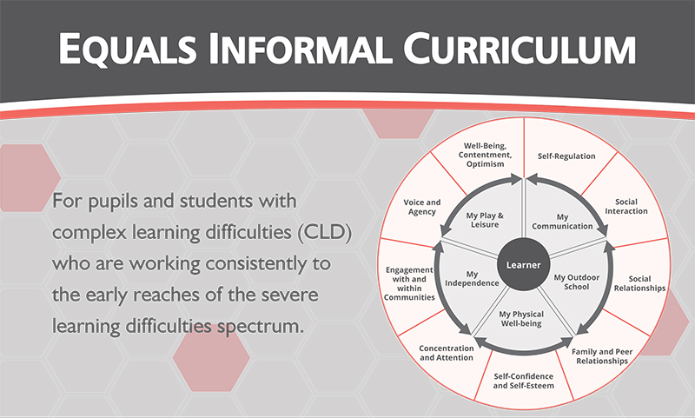

**Emerald**

The Emerald Pathway at Woodside has been designed to meet the needs of pupils with Moderate to Severe Learning Disabilities and are working below National Curriculum standards. They who autonomous across a range of contexts, have a more developed ability to engage with their environment effectively but are still continuing to develop their ability to apply their learning to varying contexts and functional situations.

The teaching approach in this pathway is aimed at developing creativity and thinking critically through an active learning approach based in exploration. In the Emerald Pathway children will begin to develop their subject specific skills such as numbers, reading and writing through an active learning approach in the subject areas of communication, thinking and problem solving, independence and creative arts.

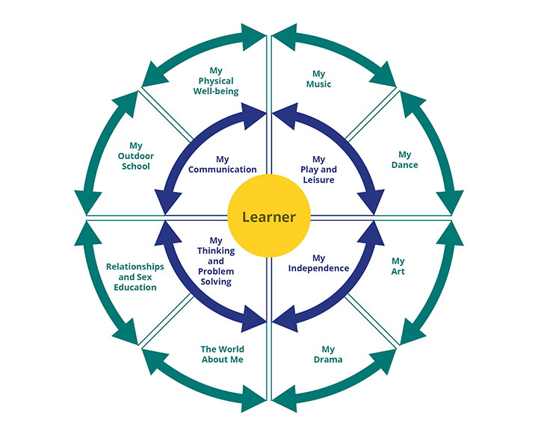

**Pearl**

The Pearl pathway has been developed to meet the needs of pupils with Moderate Learning Disabilities who are still developing the ability to apply their learning to varying contexts and functional situations but are developmentally secure enough in early subject specific learning that they can access early national curriculum. Learners in this pathway engage in subject specific learning in English, Maths & Science (World Around Me) supported by other areas of the Equals Formal Curriculum. Accreditation is provided, and pupils work towards preparation for adulthood to include independent life skills and employability with advice from a careers advisor.

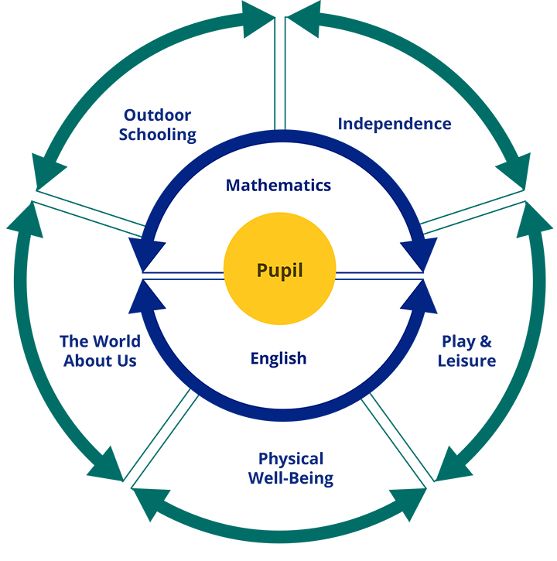

# **Therapy**

Learners in all pathways receive tailored Therapeutic input to support their holistic development. Pupils at Woodside School receive individualized therapeutic input including Speech and Language Therapy and Occupational Therapy.

A large number of pupils at Woodside School have some level of speech and language or physical, sensory, or cognitive needs. To support this, speech and language and occupational therapy is commissioned for individual pupils as required. The whole school environment is also considered with regards to ensuring that it is communication friendly. This may include teaching the pupils to use some form of Augmentative and Alternative Communication (AAC). The HCPC registered Speech and Language and Occupational therapists will deliver sessions in a number of ways, including assessments, observations, individual targeted work, whole school approaches and small group sessions.

Other Therapy that is integrated into the curriculum include PET, Play, Music, and Equine.

**Further opportunities**

The curriculum takes full advantage of all of the diverse and wonderful opportunities that being located in Central London affords us. This includes, but is not limited to:

* + Mindfulness and meditation
  + Sensory Activities
  + Visits to parks, museums, art galleries, theatres, sporting stadiums
  + Speakers to the school
  + Visits to businesses
  + College visits

**Physical activity**

Stressing importance of physical activity for development and wellness. Special attention to individual and group exercises, developing mutual support and trust among the student body.

* Sports
* Swimming
* Martial arts
* Dancing
* Gymnastics
* Nature / Forest exploration
* Expeditions & trips

Our integrated approach is encompassing of curricula such as PSHE, SMSC, RSE, and FBV. We ensure that our holistic approach focusing on building community and ownership naturally supports and integrates these into a student’s plan and journey with us. We also emphasize a strong calendar of cultural and community events and activities bringing in themes of PSHE and SMSC and creating real student experiences. Also refer to SMSC policy.

**Preparation for Adulthood**

Woodside school supports the preparation for adulthood throughout the curriculum components and through our methodology. We use the “Moving On TO” accreditation from EQUALS, in order to validate the real, practical, and functional progress made by students with learning difficulties, over their formal educational learning journeys, whether in primary or secondary. I can statements are qualified by Independence (1.with support, 2.minimal support, and 3. independently), and Maintenance (1. Has been observed on a single occasion, 2. Demonstrated on repeated occasions, but not yet consistent. 3. It is remembered after a break and can be reliably anticipated). Moving On To is a Certificated accreditation.

**CURRICULUM PLANNING**

A student’s learning incorporates elements of our broad and diverse curriculum which is mapped out for each individual, ensuring a balanced and diverse engagement is supported at all times and realising the potential of each student.

The elements incorporated include:

|  |  |  |  |  |
| --- | --- | --- | --- | --- |
| Community engagement | EHCP | Pathway schemes of work | Themes | Montessori principles |
| Incorporating community engagement strategies | Incorporating EHCP long term outcomes | Content and  Knowledge for each  curriculum area | Community wide themes on which the scheme of work activities are based | Ensuring planning aligns to our guiding values in practice |

**Baselines**

All student plans start with baseline assessments in order to better understand individual abilities and generate an evidence-based plan along the suited pathway. Students are then continued to be monitored and assessed according to our framework and the core academic pillars of maths, english, measuring progress to their expected achievement level.

**Schemes of Work**

Our curriculum schemes of work are adapted and developed to ensure they meet rigorous evidence based learning goals, content coverage, and implementation strategies aligning with our overall pedagogy. Schemes of work are then mapped out into Medium-term plans over the full schooling period. Short-term plans are created weekly in order to adapt and modify curriculum according to need and events of the week.

**Weekly schedule**

Weekly schedules or timetables will look different for every student, according to their needs, school wide themes, and interests. Individual or small groups may have therapy, outside trips, physical activity, or academic learning at any time throughout the school day. There will also be times during the school day for whole group activities including morning and afternoon Circle time, although most activities will be in smaller groups, pairs, and 1-1.

# **ASSESMENT**

MAPP (Mapping and Assessing Personal Progress), is used to facilitate that planning, assessment, and recording of progress in relation to personal learning goals. There are 4 sections to MAPP:

Mapp Planning

MAPP Assessment

MAPP Recording

MAPP Principles and processes.

MAPP outcomes are tracked and updated termly and for the students Annual Review.

**Academic aims**

* That every pupil fulfils their academic potential and is challenged appropriately to develop and learn
* That teachers, tutors and teaching assistants pursue excellence in teaching and learning for pupils with SEN, providing outstanding educational opportunities
* That our pupils develop an appreciation of learning, both individually and with others and acquire a wide range of learning skills that they can continue to develop into their adult lives
* That we create an environment in which pupils are confident in their ability and increasingly ready to take responsibility for their own learning and have an awareness of their next steps with confidence
* To provide a clear reading and phonics scheme that tracks progression and increases the rate of progression for pupils who have gaps within their education
* That literacy is a strand that permeates all subject teaching ensuring our pupils become more effective communicators through speaking and listening, reading and writing where appropriate. That literacy directly links with the speech and language input to ensure that SEN is considered during their literacy progression
* To provide additional resources, liaising with occupational therapists to take into consideration the sensory needs, motor skills and independent skills of the pupils which may present as a barrier to academic development
* To have a bespoke curriculum in both areas of the school which can be interchangeable dependent on pupil needs, aptitude and level of SEN
* To provide opportunities to learn outside the school environment, with the aim to embed learning through enrichment
* To have themed Humanities days linked directly to pupils EAL for an inclusive curriculum
* An assessment system that tracks small steps as milestones (Bromcom and Sensei Framework)
* To provide additional time within the school day for basic academic skills such as handwriting and times tables.

# **Pastoral Aims**

* That pupils develop relationships with peers and adults in a way that prepares them for life beyond school. Learning about respect, tolerance and self-reflection, empowering pupils to take responsibility for their own actions and to accept others’ opinions.
* Length of lessons that are appropriate for pupils who require sensory breaks, transition time and additional time to understand lesson content.
* A timetable that provides opportunities for “mindfulness” and meditation to support pupils with being prepare for their learning.
* That PSHE promotes the following aims and challenges discrimination, bullying and empowers pupils to understand their rights and the rights of others. With particular emphasis on safe and appropriate relationships through the RSE schemes of work
* That every pupil receives excellent pastoral care and a curriculum that follows the ethos, underpinned by British Values;
  + Mutual respect
  + Tolerance
  + Law
  + Individual liberty
  + Democracy
* A curriculum that adheres to the Equality Act, ensuring that pupils at Woodside School are not disadvantaged and that the following protected characteristics are understood by all staff and pupils (where appropriate)
  + Age
  + Disability
  + Gender re-assignment
  + Marriage and civil partnerships
  + Pregnancy and maternity
  + Race
  + Religion or belief
  + Sex
  + Sexual orientation

# **IMPACT**

We believe that our students leave Woodside having gone through a journey that leaves its mark. In particularly, students who become:

* Successful learners who make progress against their Personalised Learning Goals, enjoy learning and achieve their potential.
* Confident adults who can live safe, healthy and happy lives.
* Responsible adults who make a positive contribution to society.

# **POLICY FURTHER INFORMATION**

# **EDUCATION & HEALTH CARE PLANS AND INDIVIDUAL TARGETS**

Woodside School has a Core Timetable which is supplemented by individual pupil timetables. These individual timetables provide opportunities for pupils to work towards their own EHCP targets.

Aside from EHCP targets, each pupil has specific and individual education targets. These are displayed on the wall in the classroom and on the inside of pupil’s books. These targets are incorporated into the teachers planning.

# **PERSONAL AND SOCIAL DEVELOPMENT**

* That our pupils participate in a variety of appropriate physical activities and experience a sense of well-being and self confidence that arises from good health and fitness. A flexible approach to the timetable to provide further physical exercise opportunities to improve pupils’ mobility where appropriate to do so
* That our pupils benefit from a comprehensive personal and social education that helps them to lead happy and fulfilling lives and feel valued within their own communities
* That our pupils become more effective communicators through the provision of opportunities for speaking and listening, ready, writing, and other platforms that provide bespoke communication aids where needed.
* To provide pupils and staff with training in a range of communication platforms so that all pupils have the opportunity to communicate with others. This includes but is not limited to;
  + PECS
  + Objects of reference
  + Makaton or sign language

# **SIZE OF TEACHING GROUPS**

The core ratio for teaching groups is 4:1, however some pupils will have additional 1:1 support as determined by their EHCP. At Woodside School, we focus on abilities rather than disabilities and therefore the aim for all pupils is to be able to move away from dependency on support to become as independent in their own learning as possible.

# **MONITORING AND QUALITY ASSURANCE**

Woodside School undertakes learning walks and observations, alongside work scrutiny and peer evaluations. Staff are encouraged to self-reflect and this is led by the Head of School within supervision and during tutor/teacher meetings.

External monitoring of the quality of education is provided by commissioned school improvement partner visits.

This policy will be reviewed and updated by the Senior Leadership Team, as part of a cycle, in consultation with the appropriate staff.

# **SENCO**

As Woodside School is a small school, SENCO duties are performed by the Head of School. The Head of school works to ensure that the holistic needs of each child are met with effective and ongoing monitoring and tracking of holistic progression and attainment. It is the Head of School’s duty of care to identify the holistic needs of all pupils, working in collaboration with commissioned therapists to address and meet the EHCP outcomes for every child.

From this, the Head of School with work with the teaching staff to implement and deliver high quality SEND interventions and support to enable all pupils to reach their full potential. SEND support will be woven throughout all subjects of the curriculum.

# **PREPARATION FOR ADULTHOOD**

At Woodside School we utilise the resources provided by the National Development Team for Inclusion to ensure that we work to prepare our pupils for adulthood. Areas of focus are; employment, independent living, community inclusion and health.

**Moving On To**

Moving On To is an Accreditation aligned to the Equals Curriculum Schemes of Work, which validates the real, practical, and functional progress made by individual students with learning difficulties.

This framework enables the accreditation of personal, social, work-related, and independent living, supporting students in their journey and going on to further education.

# **RESPONSIBILITIES**

Proprietor, Head of School, Teachers, Tutors, Teaching Assistants. Learning and teaching is a shared responsibility and all members of the community have an important part to play.